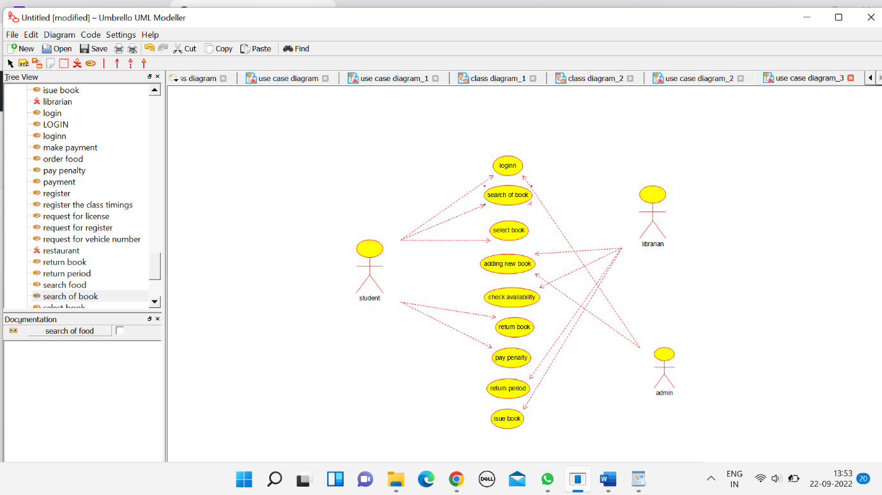

ADMIN

/**

* Class admin

*/

public class admin {

//

// Fields

//

private void name;

private void id;

private void email_id;

//

// Constructors

//

public admin () { };

//

// Methods

//

//

// Accessor methods

//

/**

* Set the value of name

* @param newVar the new value of name

*/

private void setName (void newVar) {

name = newVar;

}

/**

* Get the value of name

* @return the value of name

*/

private void getName () {

return name;

}

/**

* Set the value of id

* @param newVar the new value of id

*/

private void setId (void newVar) {

id = newVar;

}

/**

* Get the value of id

* @return the value of id

*/

private void getId () {

return id;

}

/**

* Set the value of email_id

* @param newVar the new value of email_id

*/

private void setEmail_id (void newVar) {

email_id = newVar;

}

/**

* Get the value of email_id

* @return the value of email_id

*/

private void getEmail_id () {

return email_id;

}

//

// Other methods

//

/**

*/

public void check_availability()

{

}

/**

*/

public void adding_book()

{

}

/**

*/

public void update_book()

{

}

/**

*/

public void return_period()

{

}

}

LIBRARIAN

/**

* Class librarian

*/

public class librarian {

//

// Fields

//

private void name;

private void id;

private void mobile_no;

//

// Constructors

//

public librarian () { };

//

// Methods

//

//

// Accessor methods

//

/**

* Set the value of name

* @param newVar the new value of name

*/

private void setName (void newVar) {

name = newVar;

}

/**

* Get the value of name

* @return the value of name

*/

private void getName () {

return name;

}

/**

* Set the value of id

* @param newVar the new value of id

*/

private void setId (void newVar) {

id = newVar;

}

/**

* Get the value of id

* @return the value of id

*/

private void getId () {

return id;

}

/**

* Set the value of mobile_no

* @param newVar the new value of mobile_no

*/

private void setMobile_no (void newVar) {

mobile_no = newVar;

}

/**

* Get the value of mobile_no

* @return the value of mobile_no

*/

private void getMobile_no () {

return mobile_no;

}

//

// Other methods

//

/**

*/

public void issue_book()

{

}

/**

*/

public void collect_book()

{

}

/**

*/

public void add_book()

{

}

/**

*/

public void edit_book()

{

}

/**

*/

public void delete_book()

{

}

}

STUDENT

/**

* Class student

*/

public class student {

//

// Fields

//

private void name;

private void mobile_number;

private void id;

private void email_id;

//

// Constructors

//

public student () { };

//

// Methods

//

//

// Accessor methods

//

/**

* Set the value of name

* @param newVar the new value of name

*/

private void setName (void newVar) {

name = newVar;

}

/**

* Get the value of name

* @return the value of name

*/

private void getName () {

return name;

}

/**

* Set the value of mobile_number

* @param newVar the new value of mobile_number

*/

private void setMobile_number (void newVar) {

mobile_number = newVar;

}

/**

* Get the value of mobile_number

* @return the value of mobile_number

*/

private void getMobile_number () {

return mobile_number;

}

/**

* Set the value of id

* @param newVar the new value of id

*/

private void setId (void newVar) {

id = newVar;

}

/**

* Get the value of id

* @return the value of id

*/

private void getId () {

return id;

}

/**

* Set the value of email_id

* @param newVar the new value of email_id

*/

private void setEmail_id (void newVar) {

email_id = newVar;

}

/**

* Get the value of email_id

* @return the value of email_id

*/

private void getEmail_id () {

return email_id;

}

//

// Other methods

//

/**

*/

public void select_book()

{

}

/**

*/

public void return_book()

{

}

/**

*/

public void pay_penalty()

{

}

}

